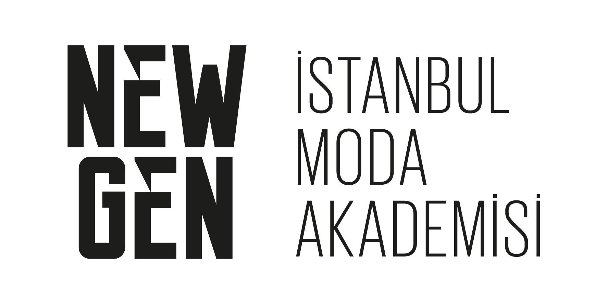

Istanbul Moda Academy
Fashion Design graduates present their collections on the stage at Mercedes-Benz Fashion Week Istanbul.

İMA NEW GEN FASHION SHOW
Spring-Summer 2019
September 12, Wednesday at Zorlu PSM

Graduates of Turkey’s most proficient fashion school Istanbul Moda Academy "Fashion Design Program" would break into the fashion industry by Spring Summer 2019 fashion show by New Gen, Istanbul Mercedes-Benz Fashion Week.

The graduation collections of the 12 young designers selected by a jury among the graduates of the İMA 2017-2018 "Fashion Design Program" have been presented at the New Gen runway at Zorlu PSM at 17:00 on Wednesday, September 12.

Graduates of İMA "Fashion Design Undergraduate and Postgraduate Programs" Bahar Yavuz, Begüm Kıran, Berk Gümüşterazili, Candan Tulga, Gökçe Kömürcü, Mertcan Öztekin, Muhammed Iloğlu, Nazlıcan Karahan, Nikta Afshar, Sümeyye Başbuğu, Şebnur Günay and Şule Gül presented their first collections.

The fashion show has been presented with the themes of; Schizophrenia, Holy Dham, After Party, Tieessix, Beauty To the Bone, Kite x 54, Dead Flowers, Hactivism, Ocean Queen, Irritate, Hope, To Look To See.

A total of 60 designs of 12 young designers, each consisting of 5 pieces met the industry.

Istanbul Moda Academy draws a road map for its students and graduates with a perspective that supports every perennial growth within its own ecosystem that is created during graduate and undergraduate programs while its students and graduates get to know the industry closely, getting ready for their professional lives and also supports Turkey's most important fashion event like MBFWI with a sense of education that carries the quality of a bridge in the sector and the vision of building strong networks.

İMA, the meeting point of today's and tomorrow's fashion professionals, celebrating the 10th anniversary with more than 10 thousand graduates, supports young talents who have completed Fashion Design education every season during the fashion week and helps them to get one step closer to their dreams.

For further information; 0212 219 41 41 (1105)
www.istanbulmodaakademisi.com

facebook.com/istanbulmodaakademi
twitter.com/imaacademy

NEW GEN

New Gen is a platform that brings new talents trained in fashion design in Istanbul Fashion Academy and the industry together and gives these young designers the opportunity to display their collections at Mercedes-Benz Fashion Week Istanbul.

Organized by Istanbul Fashion Academy with the mission of introducing the graduates of fashion design to the fashion world, New Gen Fashion Show is selected every year by evaluation by a preliminary jury consisting of select experts from the industry and included in the MBFWI calendar.

ISTANBUL MODA ACADEMY

Bringing together fashion professionals of today and tomorrow İstanbul Moda Academy (İMA) is the world-wide acclaimed fashion school in Turkey, offering an innovative and modern education in the field of fashion and all relevant branches, and celebrates its 10th year with its graduates over 10 thousands who will shape the future of textile and fashion industry.

A member of the IFFTI (International Foundation of Fashion Technology Institutes) and strategic partner of University of the Arts London/London College of Fashion, İMA pursues the goal of training fashion professionals of the future, possessing an in-depth insight in fashion, design and arts as well as an awareness of the global markets. The Academy thus aims to introduce a creative, innovative and future-steering workforce in the fields of textiles and apparel, two pivotal industries in Turkey.
İMA has become one of the most premium fashion schools of the world thanks to its competent academic staff, which is comprised of local and international experts with professional experience in the fashion industry; its up-to-date curriculum drafted in line with industrial needs; and its facility equipped with state-of-the-art technology; as well as the most comprehensive fashion library in Turkey.

